**Master’s Degree in**

**International Relations and European Studies (RISE)**

***Courses:***

***Society and Social Change in Europe***

***(Social Citizenship and Inequalities in the European and Global Context)***

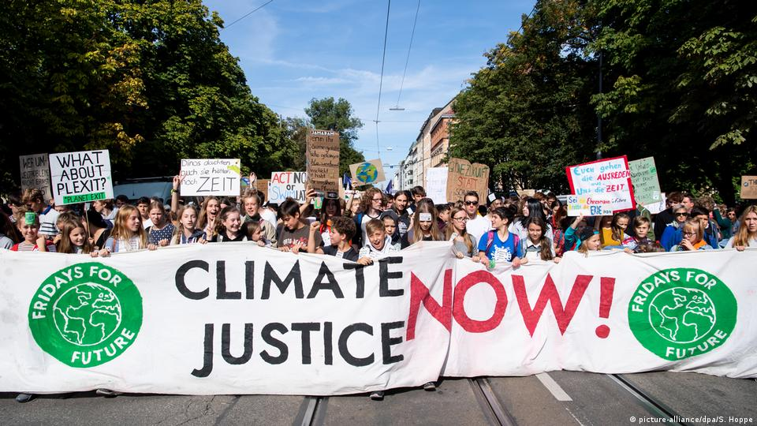

**Dr. Eugene Nulman**

Scuola Normale Superiore and University of Birmingham City

***Stopping the Climate Crisis:***

***Social Movements for Climate Justice in Europe***

**March 20th, 2023 - 04:00 p.m.**

Novoli Campus, Building D5, Room 011